Name: Ron Lavi

ID:303087357

Brief explanation about my work and about how to read this report:

I chose to demonstrate my work by comparing **SA** to **basic hill climber**.

First thing that has been done on the skeleton code is adjusting SA and HC to operate on a discrete search space.

Second and most important thing is that I introduced the idea of **"neighbor order"** and I tried to show on this report that this new concept has shown improvement not only on SA results, but also on HC results.

For example:

* HC with neighbor order 1 gave best of: 3.067 [first report]
* HC with neighbor order 2 gave best of:4.302 [second report]
* The neighbor order implied on SA has shown much better results compared to basic HC, and I have managed to get the highest value of: 5.4945054945054945 [third report]
* Finally I show that SA with "neighbor order" as a function of inner temperature, gives very stable results around 4.2 to 5.2

**neighbor order explained:** My idea here that every vector X in space has a group of **order 1** neighbors, means that all these other vectors in the group differ from x in exactly one coordinate. The **order 2** neighbors, differ from X in exactly two coordinates, etc. So my idea was that as the temperature high, the SA will be looking for high order neighbors of X and as the temperature decreases, the SA will look for lower neighbor order of X. Therefore, the variation function ("step" in my code) receives the current Temperature as an argument.

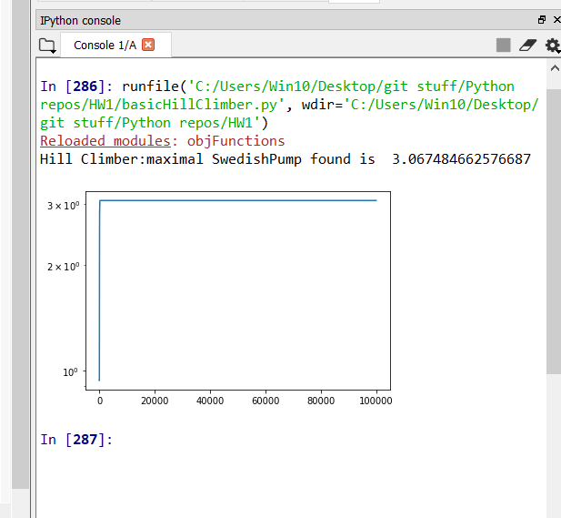**Results of Basic Hill climber with neighbor order #1:**

Best:3.067

Params:

n=100

evals=10**5

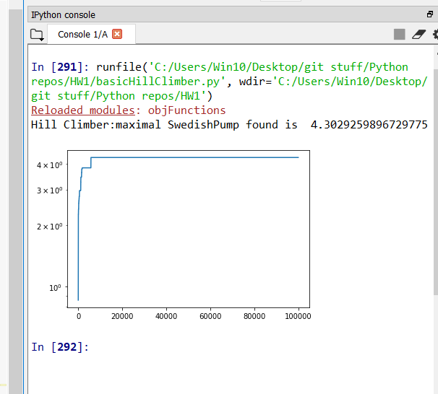**Results of Basic Hill climber with neighbor order #2:**

**Best: 4.302**

Params:

n=100

evals=10**5

**SA Best result with neighbor order #2:**

Params:

n=100

evals=10**5

0 : maximal SwedishPump found is 4.3478260869565215

1 : maximal SwedishPump found is 4.132231404958677

2 : maximal SwedishPump found is 4.47227191413238

3 : maximal SwedishPump found is 4.553734061930784

10000 evals: fmax= 1.466275659824047

20000 evals: fmax= 1.9952114924181963

30000 evals: fmax= 5.4945054945054945

40000 evals: fmax= 5.4945054945054945

50000 evals: fmax= 5.4945054945054945

4 : maximal SwedishPump found is 5.4945054945054945

5 : maximal SwedishPump found is 3.875968992248062

6 : maximal SwedishPump found is 3.57653791130186

7 : maximal SwedishPump found is 3.9001560062402496

8 : maximal SwedishPump found is 4.570383912248629

9 : maximal SwedishPump found is 4.440497335701599

==== Best ever: 5.4945054945054945

**SA with neighbor order as a function of inner temperature**

